DEPARTMENT OF MANAGEMENT
Title of the Event | HR Club
Date | 05 January 2026
Time | 3:00 to 3:30 PM
Target Audience | MBA I Semester
No. of Participants | 38
Organization | The Oxford College of Science, Arts, Commerce and Management
Topic Of the Day | Hands-On Activity on Occupational Safety, Health, and Working Conditions Code, 2020
Type of Activity | Departmental
Venue: | 312
Report prepared by | Dr.M.Surekha
Faculty In-charge | Dr.M.Surekha

Coordinators HOD Vice Principal Principal
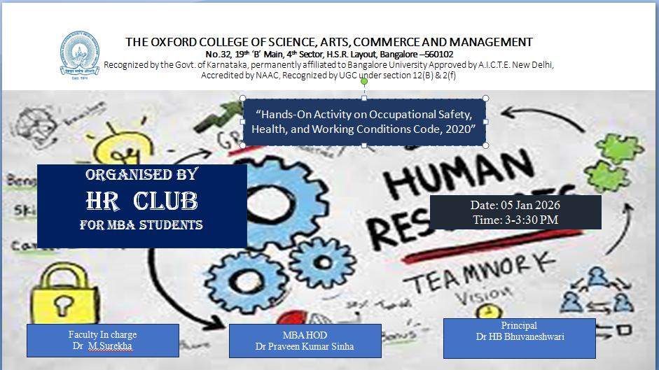

Introduction
The “Hands-On Activity on Occupational Safety, Health, and Working Conditions Code, 2020” activity of The Oxford College of Science, Arts, Commerce and Management organized during the HR club hour. The session, led by Dr.M.Surekha, MBA 1st semester students. The Hands-On Activity on the Occupational Safety, Health, and Working Conditions Code, 2020 is designed to provide learners with practical exposure to workplace safety regulations and compliance mechanisms. The activity helps students understand employer and employee responsibilities related to occupational safety, health standards, working hours, welfare facilities, and risk prevention. By engaging in this experiential learning process, participants develop critical thinking skills and gain clarity on how statutory safety norms contribute to employee well-being, legal compliance, and sustainable industrial relations. Overall, this activity bridges the gap between legislation and workplace practice, preparing learners to interpret and implement occupational safety laws effectively in professional and managerial roles.
The Hands-On Activity on the Occupational Safety, Health, and Working Conditions Code, 2020 was conducted to provide experiential learning on workplace safety legislation. Students were divided into small groups and presented with a practical case scenario representing an industrial or organizational work environment. Each group was required to identify potential safety, health, and working condition issues as per the provisions of the Code.
Participants analyzed aspects such as working hours, welfare facilities, occupational hazards, safety measures, employer obligations, and employee rights. They were encouraged to refer to relevant sections of the Code to propose corrective measures and compliance strategies. Group discussions and peer interactions were facilitated to promote collaborative learning and legal interpretation skills.
At the end of the activity, each group presented its findings and recommendations, highlighting how the Occupational Safety, Health, and Working Conditions Code, 2020 can be effectively implemented in real workplaces. Faculty members provided feedback to reinforce legal understanding and practical application.
This activity enhanced learners’ awareness of occupational safety laws, improved analytical and communication skills, and fostered a practical understanding of regulatory compliance in organizational settings.

Outcomes of the Activity
- Applied Legal Understanding
- Enhanced Analytical Skills
- Improved Communication and Negotiation Skills
- Awareness of Stakeholder Roles
Conclusion of the Activity
The Hands-On Activity on the Occupational Safety, Health, and Working Conditions Code, 2020 proved to be an effective experiential learning initiative that deepened students’ understanding of workplace safety legislation. By actively engaging with real-world case scenarios, participants were able to connect statutory provisions with practical workplace applications.
The activity reinforced the importance of occupational safety, employee welfare, and legal compliance in building sustainable and responsible organizations. It also encouraged learners to think critically about preventive measures, risk management, and ethical employer practices. Overall, the activity contributed significantly to developing industry-ready professionals with a strong awareness of labour laws and safe working environments.
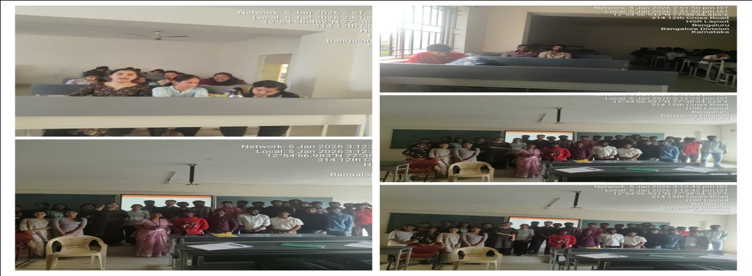

Coordinators HOD Vice Principal Principal

